Project Name: The Lemon Tree - Booking System

Aaron Jose - Computer Science Unit 5

# Index

Index 2

Discussion 3

Introduction 3

Current System 3

Aims of the Project 4

Limitations 5

Feedback 5

Presentation 5

Answering the Criticisms and Queries 5

Investigation 7

Primary Research 7

Interview 7

Questionnaire 9

Current System 10

Design 11

Objectives 11

Overview of the System 11

The Pages 12

Data Flow Diagrams (Input / Output) 12

Appendix 12

Investigation 12

The Lemon Tree Pitch 12

Design 12

Prototype 12

# Discussion

### Introduction

The Lemon Tree is a small local hotel that is in the City of Wrexham. The hotel is an independently owned and operated restaurant, bar and hotel, which has 18 bedrooms, all with ensuite.

The restaurant is primarily a family-owned business, however with the expansion in recent years has required them to rethink this and hire more employees. This expansion has led to complications in their systems, which used to be paper based and stored in files, and later destroyed. This Filing system issue combined with the dramatic increase in bookings due to the easing of restrictions put in place because of COVID-19 has caused major issues with bookings being lost and people being double booked as a result.

The manager/owner of the lemon tree would like to move from their paper-based systems onto a new computer system that allows them to complete the same tasks and do them with a higher efficiency and without the issue of having physical data that can be lost or destroyed on accident. The system should also be able to improve the booking system for the customer themselves which would solve the issue of double booking.

The restaurant employees would also like access to the system but at a lower access level, so they are able to see if a customer has booked for breakfast, lunch or dinner as well as their room. Without being able to see the details of the customers. To do this the system would also be able to book amenities (such as the restaurant) as well as rooms.

The manager initially wanted to use an off the shelf software to accomplish this however they were unable to find a suitable program that was simplistic in use, as it is a small hotel, they do not have the facilities to be trained in how to use it.

## 

### Current System

As aforementioned The Lemon Tree already has a booking system in place, however, this system has been around since the hotel opened and is still paper based. This system has many places to improve, for example a paper-based system is flawed in many ways. As it stands the system is a book, meaning only one person has access to it at any one time, and it is susceptible to data loss, as paper is very volatile and can be damaged, lost etc. A paper-based system just is not suitable for this use case, especially now after the system has been in use for many tens of years. The long-term storage of these books is a large filing cabinet which means in the event of a disaster such as a fire, all data from the previous years would most likely be lost. A new digital system would address all these problems and more.

### Aims of the Project

As I am developing this software for the manager and employees of The Lemon Tree, I need a list of Aims and Objectives that I need for my program to conform to the needs of the business. I have compiled a list of the possible needs of The Lemon Tree below.

* Make bookings that are recorded in a system along with the customer information. This system should be able to keep track of what services are being booked and if they have been booked remove the ability to book them to prevent a double booking.
* Retrieve booking information from the input of a booking id for validation of the customer
* Can be used to book amenities such as the restaurant as well as the hotel. This system should also be able to keep track of what services are being booked and if they have been booked remove the ability to book them to prevent a double booking.
* The ability to add and remove services as they become available and be taken off.
* The ability to change the prices of the rooms and services as the manager requires
* Be able to curate a financing plan for the customer to pay over a few instalments, e.g., 10% on the day of booking, and 90% on check in
* The system should also have access levels so that the manager is the only one who is able to change the prices of things along with only allowing senior management to be able to view customer details.
* To be able to make use of the access levels system the system should also contain a login system and along with this a way to create and maintain accounts
* The ability to calculate the optimum for the cleaning staff to clean and refill the rooms based off the booked days and check in and check out times

### Limitations

* The system is not required to calculate payrolls as the Lemon Tree already has a system to calculate that and will not be needed to integrate into this new system due to the limitation of this system to not be able to process and carry out card/bank transfer payments.
* For the same reason as above, the system will also not be able to carry out the card payment however it will be able to calculate the financing options
* The ability to calculate the optimum cleaning time for the cleaning staff is a very complex calculation and due to a lack of a good theory of how to complete this task. It is highly likely that this idea will not be implemented in the final package.

### Feedback

To further help myself evaluate my idea I gathered a few people and showed them a presentation curated by me showing the features and limitations that I have highlighted above and asked them what they thought about it and if they had any ideas of any other features or limitations that my system could have.

#### Presentation

The presentation is shown in the Appendix

#### Answering the Criticisms and Queries

The questions I received are summarised in answer form below:

One person can book multiple rooms, will they have to make multiple bookings for each room or just one for multiple rooms?

At the Lemon Tree there are several different amenities such as a restaurant and bar. The restaurant will be included in the booking system as the hotel would like their customers to be able to get a certain priority when booking it as they have paid for other services as well. As for the bar, as it is a bar there is no need to book it, as it is a very informal setting, so this feature will not be implemented. Another point that was brought up was parking, as The Lemon Tree already has a parking system which is low tech which just involves someone going out and checking for a little slip of paper that the hotel provides as proof of paying, in the car windshields. This will also not be added, despite the current system being an inefficient method of checking, a high-tech solution would be too complicated for the scope of this project and not available with the equipment present at The Lemon Tree. One other point brought up was the idea of booking the restaurant and bar without having to book a room, this is a good question because before I was asked this, I had not considered this. I had planned to make it another step in the process of booking a room. This caused me to rethink a lot of the design of the system. However, after speaking with the manager of The Lemon Tree, he assured me that it is unnecessary as most of the time the restaurant acts as a separate entity to the hotel, as they gather many other customers not just from the hotel. Along with the theme of the restaurant another question that was asked was if the system would also monitor the stock of the restaurant’s ingredients. This would further complicate the system to the level of possibly needing an entirely new system because the hotel employees would not need to be able to use it and would never need to see it. Because of the specific need of the restaurant and the main part of its enormous complexity I have also decided that it would be best to not include this in the final program. One of the final questions asked was how the system would prevent double bookings, this would be done by having a date that has been booked assigned to the room, this would prevent a double booking and a simple search would show all the available rooms. Which leads me onto the next question which asked how the system would prevent people from trying to book on a day which is fully booked. As the system will ask for the date being booked as the first parameter, it will perform a check to see what rooms are available and if there are none it will alert the clerk to this. Finally, the last question was a question pertaining to the ability of one booking containing many rooms or if every room had to have one booking. As I had not created the Entity Relationship Diagram as of, yet I had not figured out the logistics of this, however I am certain that the system would be able to book multiple rooms from one booking, as that would make the most sense for the user.

Those were just a few of the issues that I found that The Lemon Tree struggled with, I found this information out in the following investigation.

The investigation will contain a total of 3 various methods of gathering information.

# Investigation

Due to the long-lasting effects of the COVID-19 Pandemic the Lemon Tree had downsized back to only a handful of people most of which were new. This affected my hopes of giving a questionnaire to the employees and I decided to settle on an interview with the manager who gladly agreed. However, despite this I feel that he gave a very good response to every question and answered every question in great and most of the important and pressing problems with the system were identified.

Another issue I struggled with was that I wanted to interview another hotel, preferably a big chain, so that I could understand better what a presumably high efficiency hotel does to maintain that efficiency. However, I was unable to get in contact with anyone who could give me the permission to interview the staff.

The main points that I wanted the questionnaire and interview the staff of The Lemon Tree are as follows:

* How does the current system operate and who/how many people have access to the system.
* What data is stored in the system and how secure it is
* What happens to old data that is no longer needed (+1-year etc)
* What are the main issues
* What new features would you like to see added in the improved implementation of the system

## Primary Research

### Interview

The questions are written in black and are numbered whereas the responses are transcribed from my audio recording in red.

1. What is your Job Title at The Lemon Tree?
   1. Gathers a basic understanding of how much knowledge the person in question would have regarding the system

I am the Manager/Owner of The Lemon Tree

1. How long have you been working at The Lemon Tree?
   1. Does the same as the question above

The Lemon Tree was established in the 70s/80s and has been running as a hotel ever since. I first began working here around your age (17) underneath my father and mother around 35ish years ago now. (Making him around 52 years of age)

1. Was the system when you first started working there in the early 90s the same as it is now? Have there been any changes at all to the system since then?

No, it has not, ever since I have been working there it has not changed, at least not in my memory. To my knowledge we even use the same books as my parents did when it first opened.

1. Why have you not made the move from this paper-based system that is in use now to a computerised one of the same functionality or better.

I am honestly unsure, the most modern thing we have invested in is our website, and I have very little experience with spreadsheets and stuff like that. Although I'm not that old I would have no idea of how to set up a system like that.

1. Do you think that there is a difference in the effectiveness of paper-based systems when compared to the computerised alternatives.

Yes, I do from what I've seen of other hotels and such the computerised system is miles ahead in efficiency. Even able to have two people make bookings at the same time, although really a very simple thing is not possible with 1 book.

1. Do you think possibly part of your not reluctance but apprehension of moving to a digital system to do with an increase in the skill level needed to use the system.

Possibly, yes. Until before COVID for health concerns my mother was still working here at the desk taking bookings. Maybe part of why we never switched from a paper system was because of her. But now that she has retired, we have a new generation of people working here, such as one college student. I am more open to trialling and using a digital one.

1. How are the previous books stored?

Okay so this is quite bad, but we store them in a filing cabinet in the back of the office there. (Me: Why is that so bad?) Ah right, well with every booking we record the address and phone number of every client just in case and for legal reasons. However, as we write it down on the paper there is no security apart from the built-in key lock on the cabinet.

1. What types of data would you like to see recorded in the system?

Right, I would like to be able to make a booking obviously, and the data we would need from the customers is there: full name, telephone number and address. From the staff: full name, telephone number, address, date of birth, emergency contact information and when they started working for us

And with the booking we would need to know, what day they are checking in, the day they are checking out, their room, the number of guests and if they want breakfast. (Me: Would you also like information about the room stored in the system) Ah yes that would also be useful, information about the guest limit and if it's a family room would be useful.

1. Who would need access to this system?

Well ideally, I would be the only one with access to all the information for security reasons, but the front desk staff should be able to add details and edit the details of customers, but the details of staff should be only visible to me. I would also like our cleaners to have access to a timetable of sorts to be able to see what room is empty and when it would be next booked etc. but they should not be able to access personal details of anyone.

1. What are the downfalls of the system, its issues?

After COVID struck and my mother retired, our new front desk staff, although wonderful, struggled in the initial stages, and made a couple of double bookings and jotted down some details wrong.

### Questionnaire

1. How long have you been working at The Lemon Tree?
   1. What is your role at the Lemon Tree
2. Do you use the booking system often?
   1. If so, how often?
   2. What features do you use in the booking system?
3. What parts of the hotel would you say use the booking system the most? E.g., front desk, kitchen, cleaners, manager.
4. What data does the book allow you to store?
5. What data does the current booking system allow you to do?
6. How would you rate the ease of use of this system on a scale of 1 - 10? 1 being unusable 10 being a system that cannot be improved upon.
7. How long does one book last before another one has to be bought?
8. In your opinion is this system complex?
9. Were you given training before you were allowed to use the booking system
10. What are the downfalls of the system? e.g. How does it fail? double booking, lost booking
11. What are your overall feelings about the system? Do you think it is suitable etc?
12. Do you feel that a digital system would greatly benefit the business?
13. What would you like to add to the system if it were digitised?

The final questionnaire, written into a Google Form, was emailed to The Lemon Tree Employees as that was the easiest way of asking all of them without having to come into the hotel multiple times over the course of the week.

## Current System

Currently, the employees of the lemon tree use a paper-based system, the only digital part being the payment taking system, the rest is manually filled into a book by the member of staff at reception. This means that the bookings are written into a singular book and therefore can only be viewed by one person at a time. This causes an issue with the staff of the restaurant who need to know how many people will be dining that night, as well as the cleaning staff who need to know when the rooms are unoccupied so they can do a thorough clean. The problems with a paper-based system extend much further than just that however, as a paper-based system is subject to a range of potential data entry errors, such as spelling mistakes, loss of data etc. These are all big issues that The Lemon Tree must face daily. However, in the modern age, with the rise of the internet age, it is commonplace to be able to book a hotel from a webpage, without having to phone them or visit them in person. With the Lemon Tree's current system this is not possible, and this could possibly be a deterrent for the younger generation from booking a place at the hotel.

# Design

## Objectives

A brief recap of the Objectives that were listed previously in the investigation section.

After analysing the results from the questionnaire and the answers I gathered in the Interview, I concluded that the entirety of The Lemon Tree’s system needs a complete redesign. I found that the system needs a few key features, the most important being the ability to add bookings; secondly being the ability for multiple users to be able to view and enter data at the same time; the lastly being the ability for the generation of a timetable for the cleaning staff; There is a necessity for there to be access levels as well as staff at the front desk and the admin need access to the files of customers, whereas the people of the kitchen do not. As the system stores personal information of the customers this is a high priority task.

## Overview of the System

## The Pages

## Data Flow Diagrams (Input / Output)

# Appendix

## Investigation

### The Lemon Tree Pitch

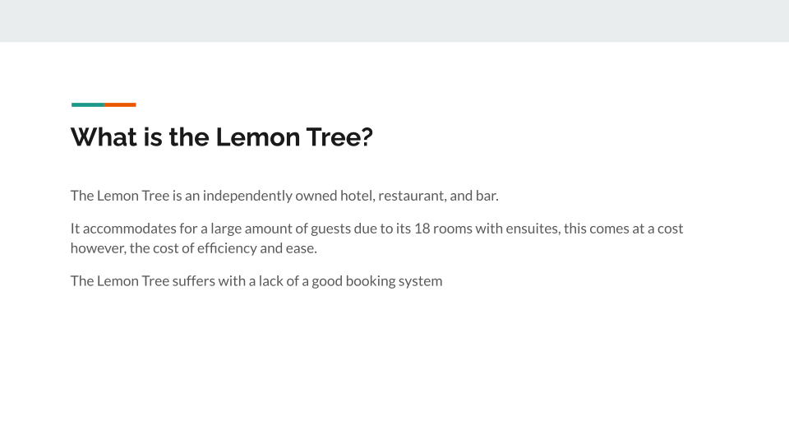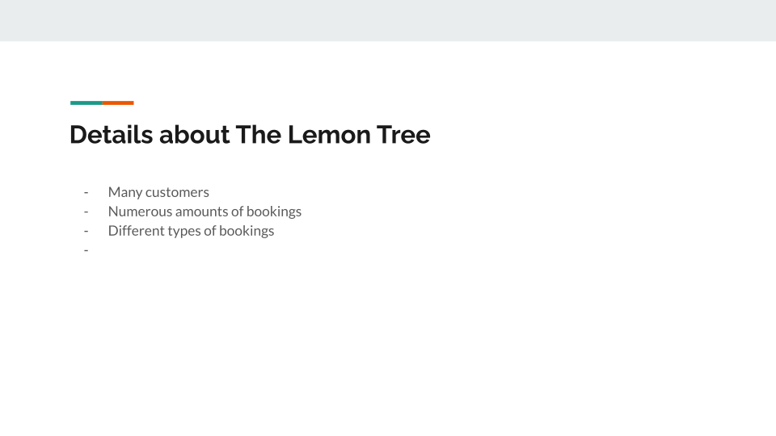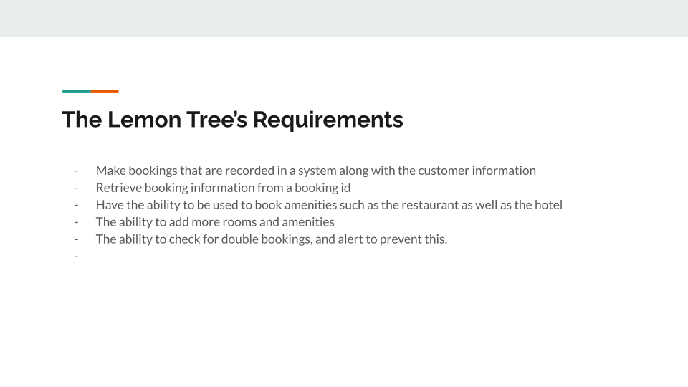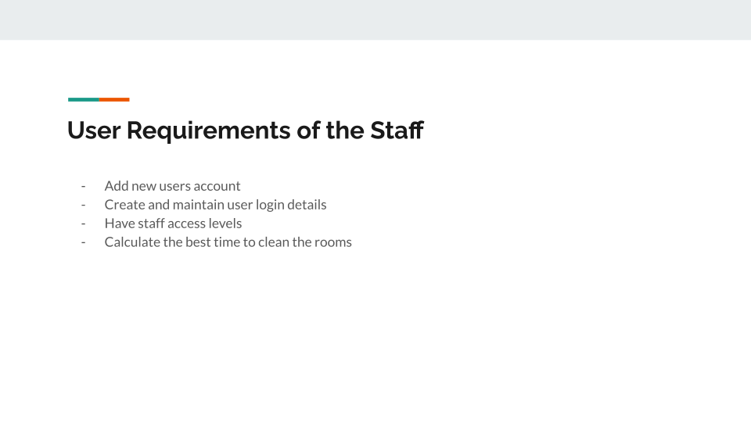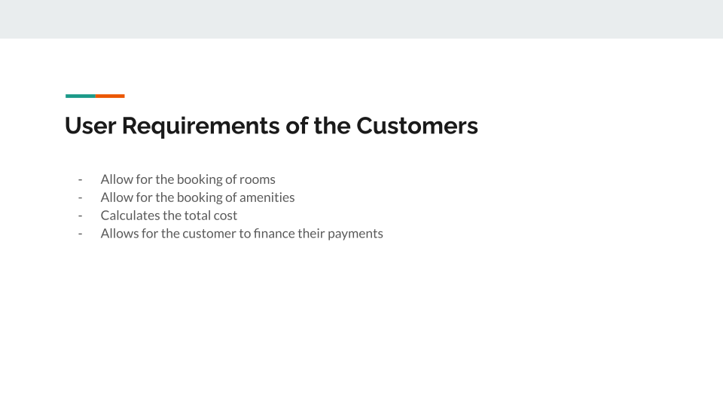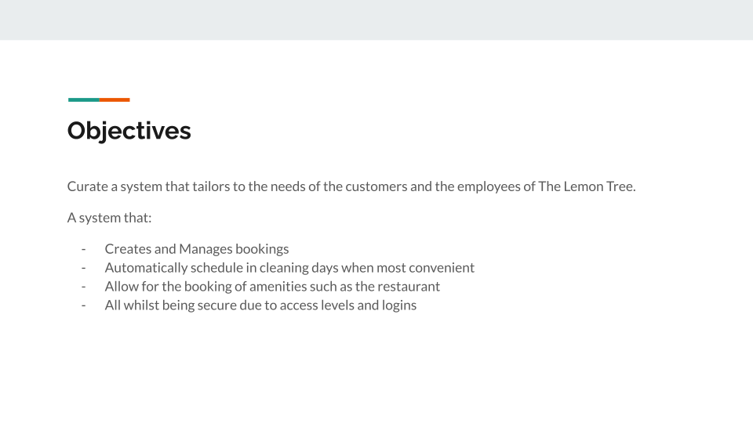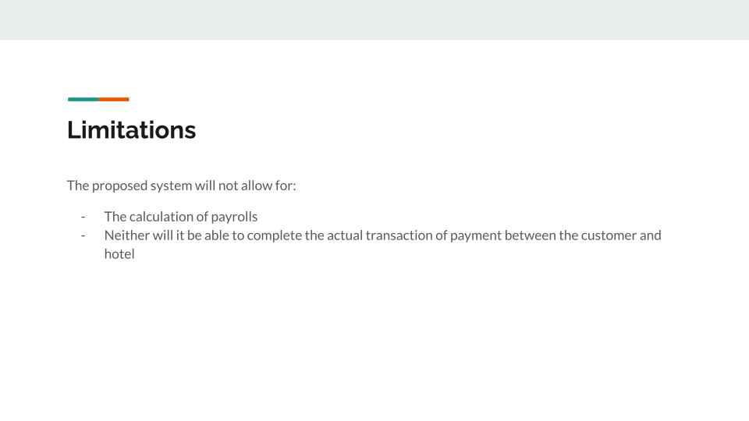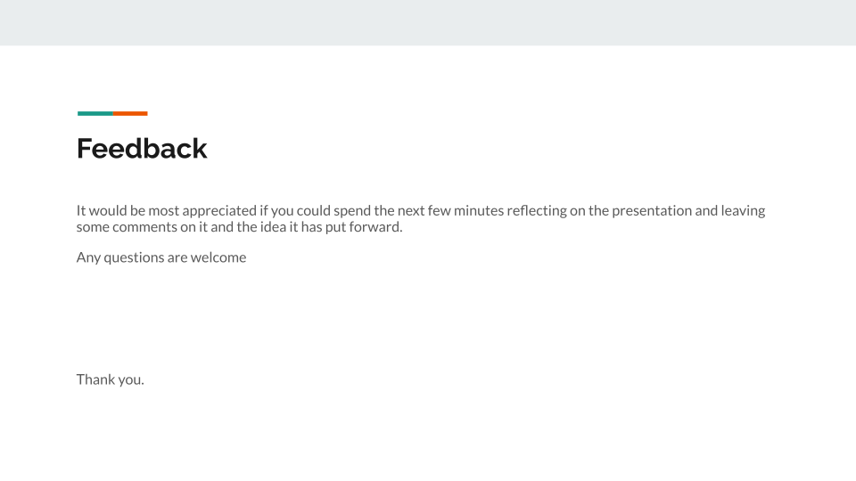

## Design

## Prototype